

# Certificate in Computing

Introduction Quiz

1. Name and explain the individual components which make up a **Computer System:**

Hardware:

* CPU (Central Processing Unit): Often called the "brain" of the computer, the CPU performs all the calculations and decision-making processes. It consists of two main parts:
  + Control Unit: Decodes instructions and tells other components what to do.
  + Arithmetic Logic Unit (ALU): Performs mathematical and logical operations on data.

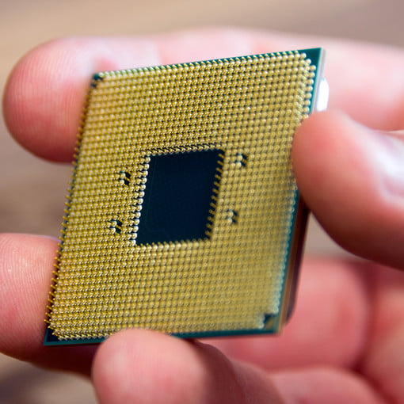

* The Heatsink/CPU Cooler: This is used to extract the tremendous amount of heat produced by the CPU.

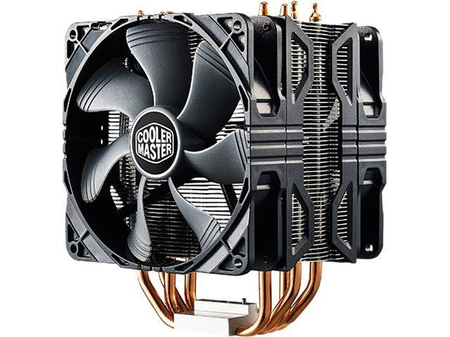

* Bus: Considered the “veins”, located on the motherboard, **high-speed data pathways** built with multiple parallel wires used to send data/instructions between components.

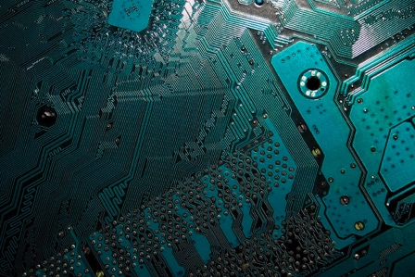

* Motherboard: This is the main circuit board that connects all the other hardware components together (the body). It houses the CPU, RAM, storage connectors, various expansion slots for other devices and input connectors.

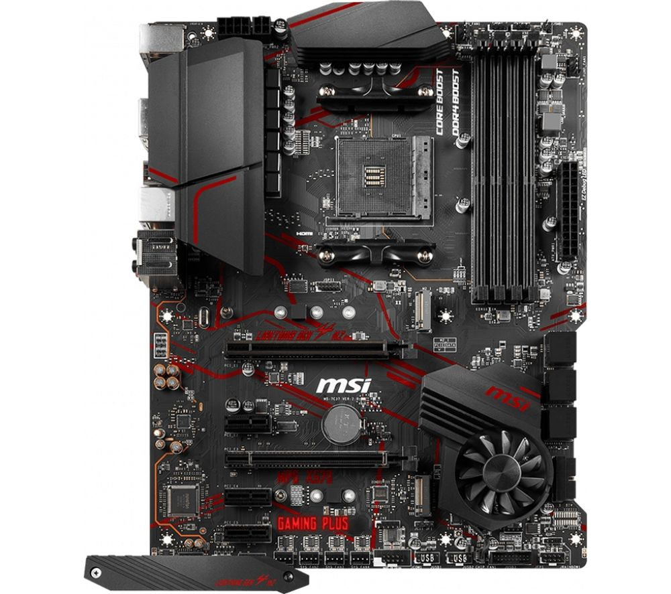

* RAM (Random Access Memory): Volatile memory that loses data when the computer is turned off. Used for temporary storage during active tasks.

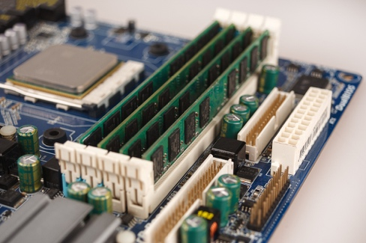

* HDD (Hard Disk Drive)/SDD (Solid State Drive): Non-volatile memory that retains data even when powered off. Where the computers data/software like the operating system and user data is stored. HDDs are made of multiple disks and moving parts that might get damaged or break after extensive use. SDDs are more modern, impact resistant and use flash memory instead of disks (also more expensive than HDDs).

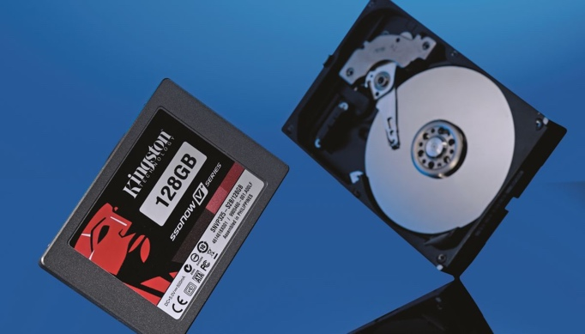

* GPU (Graphics Processing Unit): Handles graphics processing for tasks like video editing, gaming, and 3D rendering.

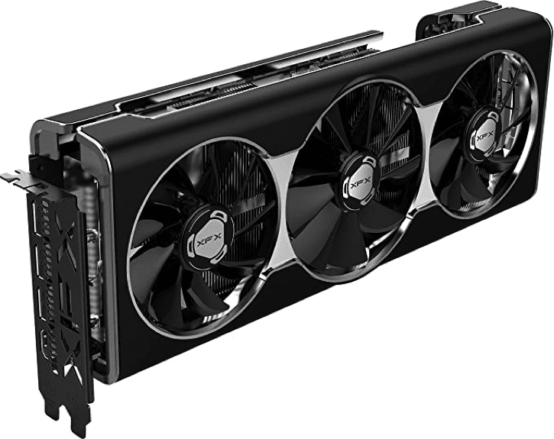

* Power Supply: Converts AC power from the wall outlet into DC power that the computer components can use.

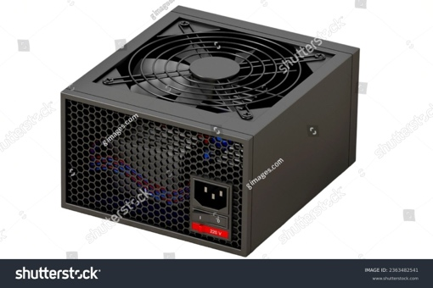

* Input: Components that allow you to enter data and instructions into the computer. Examples include keyboards, mice, scanners, webcams, microphones, etc.
* Output: Components that present information to the user.

Examples include monitors, printers, speakers, projectors, etc.



* NIC (Network Interface Card): Connects the computer to a network for communication with other devices.

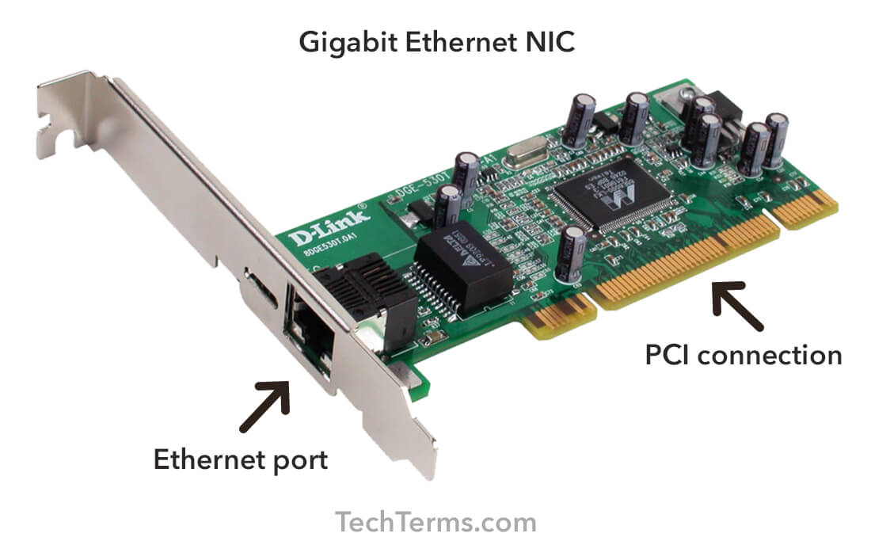

1. Name and explain the individual components which make up a **CPU**, in doing so also provide explanation of the acronyms used, e.g. CPU.

CPU means **C**entral **P**rocessor **U**nit, which consists of:

* Control Unit (CU): Acts as the brain of the CPU, fetching instructions from memory, decoding them, and directing other components to perform the necessary operations. It orchestrates the entire execution cycle, ensuring things run smoothly.
* Arithmetic Logic Unit (ALU): The ALU performs all the arithmetic and logical operations, like addition, subtraction, multiplication, division, comparisons, and bit manipulations. It's behind calculations and decision-making.
* Registers: Registers are high-speed storage units within the CPU that hold data and instructions currently being processed. They act as a temporary holding ground for immediate use, providing fast access for the ALU and the CU.
* Cache Memory: Cache memory is a small but incredibly fast type of memory located between the CPU and main memory. It stores frequently used data and instructions, allowing the CPU to access them quickly without having to fetch them from the slower main memory, significantly speeding up processing.

1. What is the Von Neumann Design?

Is a computer architecture based on three concepts:

1. **Data and Instructions stored in a single read-write memory.**
2. **The contents of memory are addressable by location, without regard to the type of data contained.**
3. **Execution occurs in a sequential manner (unless explicitly modified) from one instruction to the next.**

Computers that implement this design consist of four main components:

1. “A main memory, which stores both data and instructions.”
2. “An arithmetic and logic unit (ALU) capable of operating on binary data.”
3. “A Program control unit, which interprets the instructions in memory and causes them to be executed.”
4. “Input/output (I/O) equipment operated by the control unit.”
5. What is the recognized issue with this design?

The major problem with this design is bottleneck. This is the latency caused due to the CPU and memory being separate components, throughput is lower due to slow speed of memory than the rate at which the CPU can work forcing the CPU to continually forced to wait for needed data to be transferred to or from memory.

1. What steps can be taken to overcome this design issue?

There are a couple steps to overcome this issue:

1. Caching: storage frequently used data in a “designed area” (usually CPU Cache), so that it is readily accessible and faster to access than if it was stored in main memory.
2. Pre-fetching: “moving data into cache before it is requested to speed access in the event of a request.”
3. Multi-threading: “managing multiple requests simultaneously in separate threads.”
4. “New types of RAM (Random Access Memory): for example, Double data rate (DDR3).”
5. Explain the Acronyms below and one piece of additional information on each

|  |  |
| --- | --- |
| SSD | Solid State Drive - A storage device that uses integrated circuits to store data persistently, as opposed to the spinning platters of a traditional Hard Disk Drive (HDD). |
| HDD | Hard Disk Drive - A mechanical storage device that uses rotating platters coated with magnetic material to store data. |
| USB | Universal Serial Bus - A standard for connecting various peripherals to a computer, including external storage, keyboards, mice, printers, and more. |
| RAM | Random Access Unit - A volatile memory that stores data and instructions currently being used by the CPU. |
| NIC | Network Interface Card - A hardware component that allows a computer to connect to a network and communicate with other devices. |
| PC | Personal computer - A general term for a desktop computer designed for individual use. |
| CPU | Central Processing Unit - The brain of the computer, responsible for fetching instructions, performing calculations, and controlling the flow of data throughout the system. |
| GPU | Graphics Processing Unit - A specialized processor designed to handle graphics processing tasks, such as rendering images, video, and 3D animations. |
| ALU | Arithmetic Logic Unit - A part of the CPU responsible for performing all arithmetic and logical operations. |

1. What is Primary Storage and Secondary Storage?

**“Primary storage** is the main **storage** of the computer or main **memory** that is the random access **memory** or RAM.“

**“Secondary storage**, on the other hand, is the external **storage** devices used to store data on a long-term basis (HDD/SSD, USB sticks, etc…).”

1. What does volatile and non-volatile means in terms of computing (Memory)

**Volatile memory**: Loses data when powered off, fast for active tasks (RAM, CPU cache).

**Non-volatile memory**: Keeps data even powered off, slower but good for long-term storage (HDDs, SSDs, USBs).

1. The motherboard of a computer connects various components together but what is the method or means of communication of data within this board?

The motherboard uses buses, that carry data signals, connecting the CPU, memory, and other devices. Buses are **high-speed data pathways** built with multiple parallel wires.

Interfaces, like ports, serve as entry points for each component, allowing them to send and receive data through these buses.

1. Explain the term “ To Overclock” , specifically mention the term “Clock” and highlight at least one issue with this process and how this issue may be managed.

Overclocking is increasing the CPU clock speed beyond the intended rate to increase performance.

The main Issue that may arise is increased heat stress and potential damage.

This can be managed by improving cooling (fans, liquids) and monitor temperatures to avoid overheating.